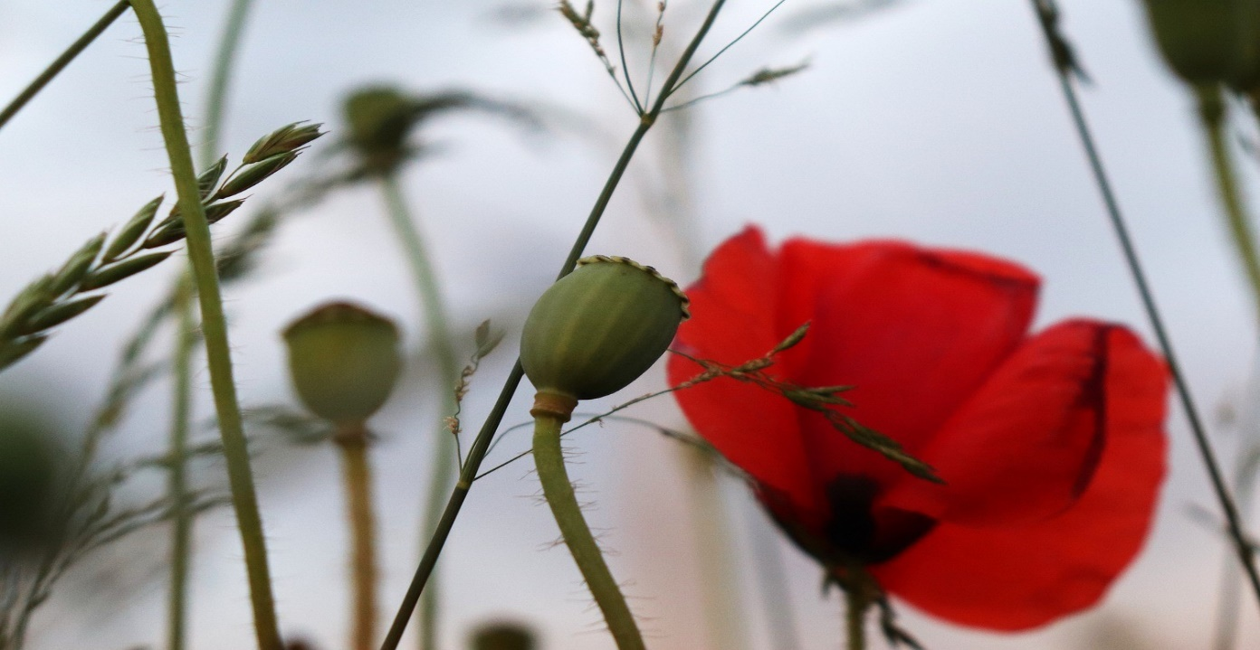

Shaldon Parish Council Remembrance Service 2020
The Green Shaldon
We regret that, due to the Governments Covid-19 restrictions we will be unable to hold a memorial service this year.
We would like to invite you to show your respect by coming to your front doors at 11am to observe the two-minute silence and applaud afterwards to commemorate our war heroes.
There will be a loud bang to start and end the two minutes.

